Project Design Phase

Proposed Solution
Date: 02 November 2025
Team ID: NM2025TMID03190
Project Name: Laptop Request Catalog Item
Team Members: Indra & Buvana
Maximum Marks: 2 Marks

Introduction:
In most organizations, employees depend on the IT department to provide laptops for work. Currently, this process is handled manually through email requests or in-person communication, which leads to delays, miscommunication, and lack of request tracking. As a result, employees experience unnecessary downtime, and IT teams struggle to manage and record asset allocation efficiently.

Proposed Solution:
To overcome these challenges, the proposed solution is to implement a **Laptop Request Catalog Item** within the ServiceNow platform. This catalog item will automate the request, approval, and fulfillment process for laptops, ensuring a smooth workflow between employees, managers, and the IT asset management team. Employees will be able to raise a laptop request through the ServiceNow service catalog, which will automatically trigger approval workflows and notify relevant stakeholders at each stage.
The system also integrates with the existing asset management module to check laptop availability before assignment. By incorporating automated workflows, notifications, and real-time tracking, the solution provides a streamlined and transparent process for managing laptop requests efficiently.

Key Modules / Components:
Module | Description
User Request Form | A catalog item form where employees can request a laptop with details such as model, reason, and department.
Approval Workflow | An automated approval system that routes requests to managers for validation before IT fulfillment.
Inventory Check | Integration with the asset management database to verify the availability of laptops before allocation.
Notification Module | Sends automated email updates to users, managers, and IT teams during each process stage.
Fulfillment Tracking | Allows IT staff to update the request status and record laptop delivery or assignment details.

Expected Benefits:
❑ Automates the laptop request process, reducing manual intervention.
❑ Provides real-time visibility into request status for employees and managers.
❑ Reduces approval and delivery time by at least 50%.
❑ Improves data accuracy and record-keeping for IT asset management.
❑ Enhances employee satisfaction and operational transparency.

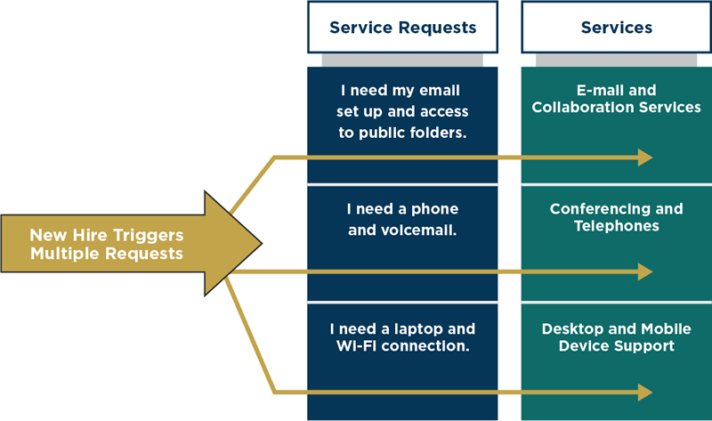

References:
https://developer.servicenow.com/

